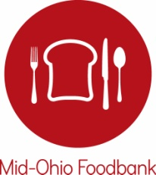

BOARD OF TRUSTEES

Chair
JON A. CARDI
Safelite AutoGlass

Vice Chair
LARALYN SASAKI DEARING
Laralyn & Associates LLC

Secretary/Treasurer
AMY GILMORE
IGS Energy

REV. VIRGINIA LOHMANN BAUMAN
St. John’s United Church of Christ

MICHELLE CHRISTENSEN
Big Lots Inc.

MARVIN CLAYTON
L Brands

DANIEL CREEKMUR
Columbia Gas of Ohio
THERESA HARRIS
TMH Solutions

MICHAEL (CASEY) HERMAN
PricewaterhouseCoopers LLC
BRIAN JEPSON
Riverside Methodist Hospital
TOM KATZENMEYER
Greater Columbus Arts Council
THOMAS L. KIRKPATRICK
American Electric Power
AERICA MEACHAM
Ex Officio Member
OSU Fisher College of Business

BOBBY D. MOSER
The Ohio State University, Emeritus
RICK REMIKER
Huntington National Bank
MYSHEIKA ROBERTS, M.D.
Columbus Public Health
RICH ROSEN
Indigo Strategies
JOSH SELL
Wendy’s QSCC
MARK STEWART
Stewbean Productions LLC

ARIANA ULLOA-OLAVARRIETA
Ohio University
KIRT WALKER
Nationwide

GREGORY P. ZUNKIEWICZ
Edward Jones
STAFF
MATT HABASH
President & CEO
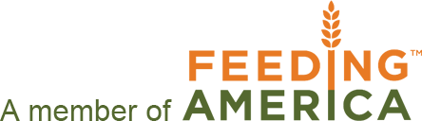

August 3, 2017

Dear Partner and Hunger Advocate,

Hunger Action Month (HAM) in September is right around the corner. This year, Mid-Ohio Foodbank is providing a Hunger Action Month toolkit to network partner agencies to help further expand on all of the great work you do in helping raise awareness during this critical month.

Hunger Action Month is a national campaign that runs the entire month of September. The campaign brings greater attention to hunger in Ohio and our communities and promotes ways for people everywhere to get involved in the movement to fight it.

There could not be a more important time to commit to doing everything we can in the fight against hunger, as many individuals in communities all across Ohio are still struggling in our recovering economy. Sadly, 1 of 4 children in Ohio and 1 of 6 Ohioans don’t know where their next meal is coming from.

To inform others in the community about hunger, we are asking our partners to utilize this toolkit during Hunger Action Month. In the toolkit you’ll find the following:
- Social Media Messaging (based off the Hunger Action Month calendar)
- Advocacy/Legislative Priorities
- Press Release Templates
- Branded Foodbank Merchandise Order Form
- County Resource Cards
- SNAP Challenge Toolkit
- Hunger Facts
- Hunger Action Month Calendar

Useful Links:
Mid-Ohio Foodbank’s Hunger Action Month web page here.
Feeding America Map the Meal Gap county specific information here.
Find your elected officials here.

Key Messaging: Get a Fresh Perspective on Hunger
Get a Fresh Perspective by focusing attention on the shift towards fresh food. Get a Fresh Perspective by taking a different look at our hungry neighbors and focusing on their resiliency. Get a Fresh Perspective by looking at ourselves – and the judgements we may knowingly, or unknowingly, put forth.

HAM Calendar Themes Defined:
This year’s HAM Calendar is focused around a different theme each week.
Week 1: Hunger & Health – At Mid-Ohio Foodbank, it’s all about connecting good, nutritious food to our hungry neighbors.
Week 2: Hunger & Learning – Mid-Ohio Foodbank knows that hungry families want to learn more about balanced meals.
Week 3: Hunger & Work – Half of the people served by Mid-Ohio Foodbank work but struggle to make ends meet.
Week 4: Hunger & Home – More than half the people served by Mid-Ohio Foodbank choose every day between food and shelter for their families.

If you have any questions in the meantime about Hunger Action Month or the toolkit, please contact Marilyn Tomasi, Vice President of Marketing & Communications/Public Affairs at mtomasi@midohiofoodbank.org or Jill Jess, Media Relations Manager, at jjess@midohiofoodbank.org. Thank you for your partnership and efforts to build a hunger-free and healthier Ohio.

Sincerely,
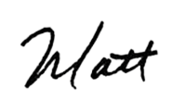
Matt Habash
President & CEO

