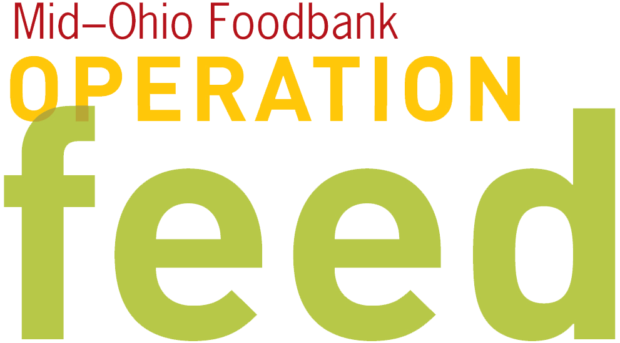 ENGAGEMENT EMAIL
This email shares your Operation Feed plans.
Replace blue highlights with information specific to your campaign.
- Goal - Once you’ve registered, Operation Feed will provide a suggested goal based on past employee per capita giving and designed to ensure that the campaign meets the community food needs.
- The activities and donation paragraph is designed to highlight activities you’ll be using to raise meals for Operation Feed.

SUBJECT:
1 in 4 Ohio children is at risk of hunger.

Fellow Employees—
As many of you know, [organization name] will be participating in the 2015 Operation Feed campaign. This campaign is a fundraising drive that supports Mid-Ohio Foodbank, allowing them to provide fresh, healthy food for families in central and eastern Ohio who are struggling to make ends meet.

Our goal for 2016 is to raise $_____, which equals [$ amount x4] nourishing meals for those facing hunger. 100% of funds donated to Operation Feed will be used to provide food to hungry people.

This year’s drive is scheduled for [campaign dates/timeframe]. Throughout this time, we’ll be raising funds to support children, seniors, and others right here in our community. Now is our time to make a difference in our community and make 2016 our most successful campaign yet.

By joining our campaign, you’ll be helping people like Pat. She was a homeowner who attended college classes, worked as a nurse’s aide, and raised four children until it all fell out from under her. Pat’s life changed when serious health issues and medical expenses completely drained her resources.

With help from Mid-Ohio Foodbank’s Mobile Market she receives fresh fruits and vegetables, milk, yogurt, and bread right where she lives. “These foods are conducive to my diet, not destructive to my diet,” said Pat, who manages diabetes through her healthy food choices.

Now Pat can choose free fresh foods that get her through the month and support her health.

[SAMPLE: Whether you are a chili expert, baking pro or Euchre champ, there are a number of ways to give back through our Operation Feed campaign. And, one of the most convenient and impactful ways to help is a secure online donation at http://www.midohiofoodbank.org/operationfeed / signing up for payroll deduction through the HR department. A recurring monthly donation spreads out the impact of your gift and helps local families all year long!]

Our Operation Feed campaign often inspires friendly competition and tons of fun around the office, as well as raises funds for a great cause. I encourage you to get involved. Together, we can help Mid-Ohio Foodbank build a hunger-free and healthier community.

Sincerely,

[Campaign Coordinator name here]

