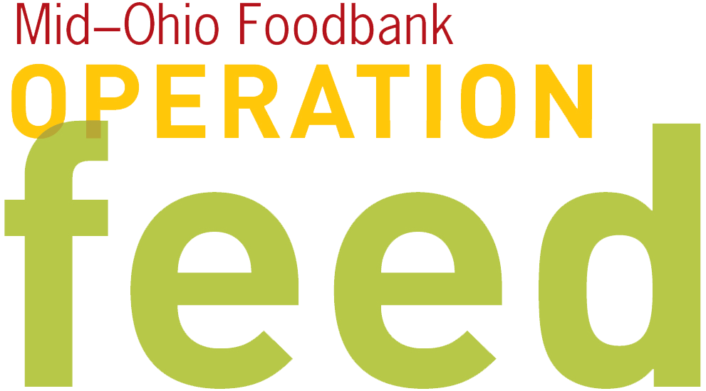 CAMPAIGN ANNOUNCEMENT
This letter shares the start of Operation Feed with all of your associates.
Replace the blue highlights with information specific to your campaign.

[Organization name] Employees—
We need your help.

Our 2016 Operation Feed campaign will be held [campaign dates]. During this time, we’ll be supporting Mid-Ohio Foodbank. This community organization distributes over 59 million pounds of food—over half of which is fresh fruits, vegetables, meat, dairy, and bread—each year to local families. We need your support as [Organization name] participates in this community-wide initiative to end hunger, one nourishing meal at a time.

The most important thing you can do is to join our campaign by getting involved. Participate in Operation Feed events, and donate to the cause. Every $1 we raise provides four meals. That means that each $3 donated can feed a family of four for a whole day! Please encourage everyone in your department to join in the fun—this is a great opportunity for us to work together and help our neighbors who are struggling to put food on the table.

I know that many of you actively support Operation Feed, and we are grateful for your efforts and commitment. Remember, we have the opportunity to make a huge difference in the lives of more than half a million people facing hunger in central and eastern Ohio.

As a team, I know we can work together to help end hunger in our community. Thank you for your support and enthusiasm for this campaign and Mid-Ohio Foodbank’s work to build a hunger-free and healthier community.

Sincerely,

[Leadership / Campaign Coordinator name here]

