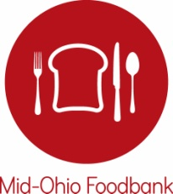

BOARD OF TRUSTEES

Chair
JON A. CARDI
Safelite AutoGlass

Vice Chair
LARALYN SASAKI DEARING
Laralyn & Associates LLC

Secretary/Treasurer
AMY GILMORE
IGS Energy

Immediate Past Chair
TOM KATZENMEYER
Greater Columbus Arts Council

MARVIN CLAYTON
L Brands
THERESA HARRIS
TMH Solutions
ZACHARY HYNDMAN
Ex Officio Member
OSU Fisher College of Business
BRIAN JEPSON
Riverside Methodist Hospital
THOMAS L. KIRKPATRICK
American Electric Power
BOBBY D. MOSER
The Ohio State University
WILLIAM P. OWAD, JR.
Cardinal Health

RICK REMIKER
Huntington National Bank
MYSHEIKA WILLIAMS ROBERTS
Columbus Public Health
RICH ROSEN
Indigo Strategies
MARK STEWART
Alliance Data, retired
ARIANA ULLOA-OLAVARRIETA
Columbus State Community College
KIRT WALKER
Nationwide

GREGORY P. ZUNKIEWICZ
Edward Jones

STAFF
MATT HABASH
President & CEO

3960 Brookham Drive

Grove City, Ohio 43123

614.274.7770
info@midohiofoodbank.org
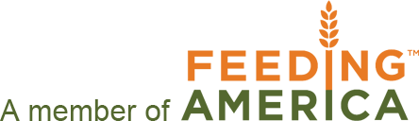
www.midohiofoodbank.org

August 10, 2016

Dear Partner and Hunger Advocate,

Hunger Action Month (HAM) in September is right around the corner. This year, Mid-Ohio Foodbank is providing a Hunger Action Month toolkit to network partner agencies to help further expand on all of the great work you do in helping raise awareness during this critical month.

Hunger Action Month is a national campaign that runs the entire month of September. The campaign brings greater attention to hunger in Ohio and our communities and promotes ways for people everywhere to get involved in the movement to fight it.

There could not be a more important time to commit to doing everything we can in the fight against hunger, as many individuals in communities all across Ohio are still struggling in our recovering economy. Sadly, 1 of 4 children in Ohio and 1 of 6 Ohioans are food insecure.

To inform others in the community about hunger, we are asking our partners to utilize this toolkit during Hunger Action Month. In the toolkit you’ll find the following:
- Social Media Messaging (based off the Hunger Action Month calendar)
- Advocacy/Legislative Priorities
- Press Release Templates
- Branded Foodbank Merchandise Order Form
- County Resource Cards
- SNAP Challenge Toolkit
- Hunger Facts
- Hunger Action Month Calendar
- Panera coupon to share with public

Useful Links:
Mid-Ohio Foodbank’s Hunger Action Month web page here.
Feeding America Map the Meal Gap county specific information here.
Find your elected officials here.

Key Messaging: Get a Fresh Perspective on Hunger
Get a Fresh Perspective by focusing attention on the shift towards fresh food. Get a Fresh Perspective by taking a different look at our hungry neighbors and focusing on their resiliency. Get a Fresh Perspective by looking at ourselves – and the judgements we may knowingly, or unknowingly, put forth.

HAM Calendar Themes Defined:
This year’s HAM Calendar is focused around a different theme each week.
Week 1: Food & Learning – Every day a child goes to school hungry is one more day of lost learning.
Week 2: Food & Home – Deciding between food & shelter seems impossible, but is a choice some families make every day.
Week 3: Food & Income – Not earning a sustainable wage cane make it difficult for families to provide consistently nutritious meals.
Week 4: Food & Health – The cost of fresh food for low-income families is a barrier to good health.

If you have any questions in the meantime about Hunger Action Month or the toolkit, please contact me at ahoman@midohiofoodbank.org or call at 614-317-9480. Thank you for your partnership and efforts to build a hunger-free and healthier Ohio.

Sincerely,
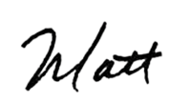
Matt Habash
President & CEO

