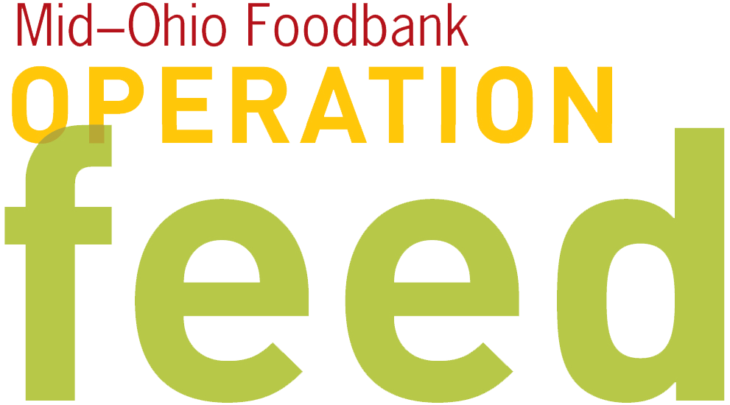 ONLINE DONATION REMINDER
Utilize this template to encourage people to use the quick and easy online giving option.
Fill in blue highlights with information specific to your campaign.

SUBJECT:
Your gift is more than a meal!

Fellow Employees –
As many of you know, [organization name] is participating in the 2016 Operation Feed campaign. This fundraising drive supports Mid-Ohio Foodbank in the fight to end hunger in central and eastern Ohio. It provides fresh, healthy food for neighbors struggling to put food on the table.

Today, one in six Ohioans is food insecure: they don’t know where a next meal is coming from. As a leader in our community, it is [organization name]’s responsibility to be part of the solution. We’ve taken the charge, together, to help those in our community who need it.

The most convenient way to join our campaign is by giving online. Visit http://www.midohiofoodbank.org/operationfeed. Choose [organization name] on the donation page, where you can make a one-time or monthly contribution (and settle up on any outstanding activity IOUs). Each dollar we raise provides four nutritious meals for a local family, and 100% of each donation to Operation Feed provides food.

Thanks for your generosity,

[Your name here]

