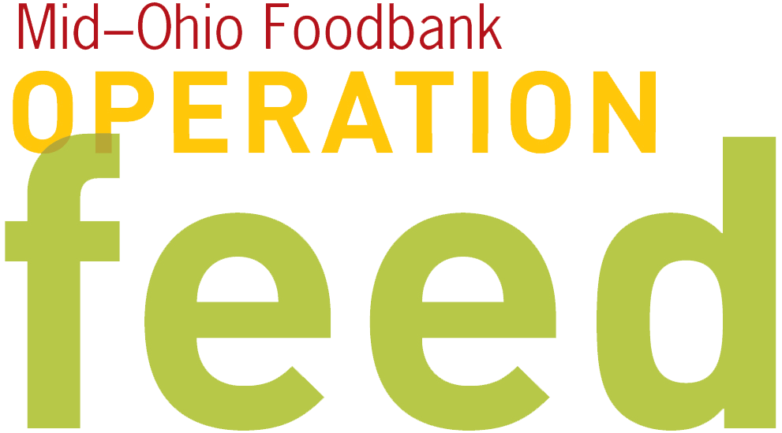 LEADERSHIP GIVING APPEAL
Provide this letter to your Leadership Champion for distribution to other leaders in your organization.
Fill in blue highlights with information specific to your campaign.

[organization name]’s Operation Feed campaign is off to a great start. Our goal for this year’s campaign is to raise $___, which will provide [$ amount x4] meals for individuals and families in need. 100% of funds donated to the Operation Feed campaign will be used to provide food to hungry people in our area. As a leader and role model to the other employees at [organization name], I encourage you to join our 2016 campaign at the leadership level gift of $____. With your help, we can reach our goal.

More than 524,000 individuals receive emergency food each year through Mid-Ohio Foodbank. Last year, they distributed over 59 million pounds of food and groceries, enough to provide 130,066 meals each day. An incredible 55% of Mid-Ohio Foodbank’s distribution is fresh foods – fruits, vegetables, meat, dairy and bread, positively impacting the health of those accessing the emergency feeding network. For every $1 received from our campaign, Mid-Ohio Foodbank can provide 4 meals because of their partnerships with grocers, food companies, Ohio farmers, the USDA, and community partners. That’s quite a significant impact!

Mid-Ohio Foodbank’s mission is to end hunger one nourishing meal at a time and co-create a sustainable community where everyone thrives. To accomplish this, they collect, warehouse and distribute food to a network of over 650 partner agencies serving 20 counties, including food pantries, soup kitchens and shelters. Mid-Ohio Foodbank also operates special programs designed to improve access to fresh food and meet the basic nutritional needs of our community’s most vulnerable members. We hope that you will give generously to help others in need.

I ask you to take a minute today to [donation method/instructions—check, online donation, etc.]. Keep in mind that a recurring monthly donation spreads out the impact of your gift and helps local families all year long! Your pledge will be added to the total meals raised by our organization. If you’ve already made your contribution to our Operation Feed campaign, thank you!

The campaign closes on [campaign end date]. Please make sending in your contribution a priority. Your leadership is important in encouraging all associates to get involved.

Thank you for your continued support of our community involvement and of Mid-Ohio Foodbank’s Operation Feed campaign!

Sincerely,

[Leadership Champion name here]

